תלקיט 2020

12 ש"ל
08.2020
אלונה לרר
רכזת אנגלית

Portfolio for 12 year diploma.
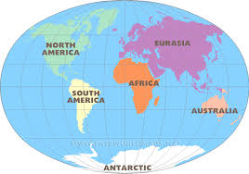
It`s a wonderful world! Let's take the time to go around it! This time we have a 6 continent Portfolio.

Continent | Maximum points | Your student`s result
Eurasia -Unseens | 60  Choose 6 texts
Africa - Vocabulary | 15
North America - Listening | 5
South America - Writing | 5
Antarctica - Speaking | 10
Australia - Grammar | 5

ציון סופי

Unseen #1

Penguins on a Trip
Penguins walk in an aquarium (אקוריום) in Chicago. There are no visitors. The aquarium is closed to visitors because of coronavirus. The penguins walk around. They watch the fishes.
Caretakers (המטפלים בחיות) let the penguins walk freely in the aquarium. Caretakers say that it is important for the penguins. They can behave naturally. They are happy and active. Other animals are sometimes free, too. It is common (רגיל) in the aquarium. The caretakers want all animals to be happy.
Caretakers make a video of the penguins. Many people watch the penguins on the Internet. People like the video a lot. They want more videos with more animals.
Answer the questions

1. Why do penguins walk around the aquarium?
a. There are no visitors. This allows penguins to walk freely.
b. The aquarium is closed because of the spread of the coronavirus.
c. The penguins watch the fishes.

2. Why is it important for the penguins to walk freely in the aquarium?
a. The penguins can behave naturally.
b. The caretakers want the animals to be happy and active.
c. Both answers are correct.

3. Which fact is NOT mentioned in the text?
a. People like the videos that the caretakers made of the penguins.
b. Other animals can also walk freely in the aquarium.
c. Coronavirus makes it difficult to take care of the animals in the aquarium.

https://app.wizer.me/editor/y49hKE6CbzGp

Unseen #2
“A letter to a friend”.
https://lingua.com/english/reading/letter-to-a-friend/

A Letter to a Friend
I
Hi, Fred!
It's been a while since we have been in touch. How has your semester been? I wanted to send you an email update to let you know how things have been going during my semester abroad here in Málaga, Spain. I've already been here for six weeks, and I feel like I am finally adapting to the culture. I'm also speaking the language more fluently.
II
I arrived during the first week of September. The weather has been very nice. Even though it's October, it's still rather sunny and warm. In fact, I went to the beach and swam in the Mediterranean Sea earlier today.
III
I am living with a very welcoming host family. I have my own private bedroom, but we eat breakfast, lunch, and dinner together. On Sundays, we eat a big home-cooked paella for lunch. In Spain, lunch is usually the biggest meal of the day. It's also very common for the people to take a midday nap right after a big meal. I am actually just waking up from my nap right now!
IV
On weekdays, I take classes at the local university. There, I met several native Spanish speakers. They have been very kind and patient with me. At first, I struggled to comprehend their Spanish, but now I understand most of our conversations. They have commented that my Spanish has improved a lot since we first met. Now, I am more confident to use the language in other places like stores and restaurants.
V
I am so glad that I decided to spend the semester here in Spain. We have an extended weekend coming up, so a group of my friends and I are going to travel to France for four days. It's so easy and inexpensive to travel internationally in Europe. I love it!
VI
I look forward to hearing from you soon. Like I said, don't hesitate to stay in touch more often. Perhaps you could even come to visit! What do you think?
Best wishes, Patrick

Answer the following questions:
1) Why is Patrick writing to Fred? (Paragraph I) (10 points)
a) To give Fred travel advice
b) To update Fred about life abroad
c) To wish Fred a happy birthday
d) To offer Fred a job in Spain

2) How long has Patrick been out of the country? (Paragraph I) (10 points)
a) One week
b) One month
c) Six weeks
d) Six months

3) Based on the letter, Málaga is most likely located: (Paragraph II)
(10 points)
a) On the coast
b) In the mountains
c) In a valley
d) In Madrid, the capital

4) The best definition of "paella” is: (Paragraph III) (10 points)
a) A frozen beverage
b) A common meal
c) A sweet dessert
d) A small snack

5) What does Patrick do from Monday to Friday? (Paragraph IV) (10 points)
a) Offer English lessons
b) Go out with friends
c) Travel internationally
d) Take college classes

6) Where does Patrick plan on traveling during the extended weekend? (Paragraph V) (10 points)
a) Spain
b) France
c) England
d) Germany
Unseen #3
אנגלית מבחן דגם 12 קיץ 2020

Teenagers ask Dr. Morris for advice
October 27, 2019
Dear Dr. Morris,
I I'm a senior* in high school, and with school coming to an end, I am trying my hardest* not to go crazy* because I'm nervous about facing* "the real world." I feel myself becoming less and less motivated by school and at home. I talk to my mom about it, but sometimes I feel like she doesn't understand. What should I do?
Brianna
Hi Brianna,
II What you're feeling is perfectly normal. You're facing* change, just like everyone your age. You should take up* a new hobby or develop a skill that will benefit you in the future. If you don't feel that your mom understands you, talk to your friends or other relatives, those who went through* the same recently. If your anxiety* about the future becomes too intense, make an appointment with a school counselor* or social worker, who can help you with strategies.
Best wishes,
Dr. Morris
Adapted from http://www.askdrm.org/col_teens.html

מחסן מילים – مخزن الكلمات
* a senior | תלמיד יב (שנה אחרונה) | صف التخرج
* trying my hardest | עושה את מירב המאמצים | يبذل قصارى الجهد
* go crazy | להשתגע | يفقد عقله
* taking up | לאמץ (תחביב) | يتخذ
* go through | לעבור | يمر خلال
* anxiety | חרדה | قلق
* facing | מתמודד עם | يتعامل مع

ענה באנגלית על השאלות 1-5 أجيبوا بالإنجليزية عن الأسئلة 1-5 על פי המכתבים שלפניך. وفقاً للرسائل التي أمامكم.
בשאלו1,3 הקף במעגל את في الأسئلة 1, 3 ضعوا دائرة
המספר של התשובה הנכונה. حول رقم الإجابة الصحيحة.
שאר השאלות ענה לפי ההוראות. في بقية الأسئلة، اتبعوا الإرشادات.
50) נקודות( 50) درجة(
Answer questions 1-5 in English according to the letters.
In questions 1, 3 circle the number of the correct answer; In the other questions, follow the instructions. (50 points)

1. What problem does Brianna mention in paragraph I?
i) She worries about the real world.
ii) She wants to stay in high school.
iii) The school isn't coming to an end.
(10 points)
2. Who does Brianna talk to about her problem? (paragraph I) (10 points)
ANSWER:____________________________________________________________________________________________________________________

3. Dr Morris tells Brianna (-) (paragraph II)

i) to see her doctor.
ii) to talk to her mother more often.
iii) to develop new skills and start a new hobby.
(10 points)

4. CIRCLE THE CORRECT ANSWER: YES or NO. (paragraph II)

1) Dr. Morris tells Brianna to talk to people who were in the same situation.
YES / NO (5points) 2) Copy the words that justify your answer.
__________________________________________________________________________________________________________________________. (5 points)

5. Complete the sentence. (paragraph II)
If you start to worry about your future too much, you should talk to a ________________________________ or social worker. They can help you with _________________________________________________________. (10 points)

February 27, 2020
Dear Dr. Morris,
III I really love your website, and I read it all the time for advice. Now I have a problem. I need to know how to deal with emotional problems so I can act like a mature* teenager and be strong during sad times.
Thank you,
Jonas

Dear Jonas,
IV I can see how mature* you are when you ask about strategies how to deal with your emotions. While you may want to stay "strong" when you're sad, it's also very important that you let yourself express* your true feelings. The key is knowing where, when, and to whom you can show those feelings.
V Think about people close to you who can support you when you're feeling stressed or sad and won't judge you for being emotional* sometimes. Also, keep in mind* that if sad feelings last longer than a few weeks, you may want to get professional help from a therapist*.
Best wishes,
Dr. Morris

Adapted from http://www.askdrm.org/col_teens.html

מחסן מילים – مخزن الكلمات
* mature | בוגר | ناضج
* express | להביע | يعبر عن
* emotional | רגשי | عاطفي
* keep in mind | זכור | تذكر
* therapist | איש טיפול | معالج

ענה באנגלית על השאלות 6-10 أجيبوا بالإنجليزية عن الأسئلة 6-10 על פי המכתבים שלפניך. وفقاً للرسائل التي أمامكم.
בשאלות7 ,8 , 10 הקף במעגל את في الأسئلة 8,7 , 10 ضعوا دائرة
המספר של התשובה הנכונה. حول رقم الإجابة الصحيحة.
בשאר השאלות ענה לפי ההוראות. في بقية الأسئلة، اتبعوا الإرشادات.
50) נקודות( 50) درجة(
Answer questions 6-10 in English according to the letters.
In questions 7, 8, 10 circle the number of the correct answer; In the other questions, follow the instructions. (50 points)

6. What problem does Jonas mention in paragraph III?
ANSWER: __________________________________________________________________________________________________________________ _________ (10 points)

7. According to Jonas, a mature* teenager is someone who (-)(paragraph III)
i) asks for advice on the website.
ii) knows how to deal with emotional* problems.
iii) has emotional* problems. (10 points)

8. According to Dr. Morris, Jonas is mature because (-) (paragraph IV)
i) he may stay strong when he is sad.
ii) he knows when to show his real emotions.
iii) he asks about the ways to deal with his emotions.
(10 points)

9. CIRCLE THE CORRECT ANSWER: YES or NO. (paragraph IV)

1) Dr. Morris tells Jonas to show his real feelings when he is sad.
YES / NO (5 points)
2) Copy the words that justify your answer.
_____________________________________________________ (5 points)

10. What should Jonas do when he feels sad for a long time?
(paragraph V)
i) He should get help from a therapist*.
ii) He should talk to his friends.
iii) He should keep his feelings in mind*.
(10 points)

Unseen #4

https://www.hila-matnasim.org.il/productImages2/262/2019/09/18/image1568793611.pdf
PART I: ACCESS TO INFORMATION FROM WRITTEN TEXTS (100 points)
פרק ראשון: הבנת הנקרא (100 נקודות) الفصل الأول: فهم المقروء (100 درجة(
קרא את הסקר שלפניך, اقرأوا الدراسة الاستقصائية التي أمامكم، וענה על השאלות 19- שאחריו. ثمّ أجيبوا عن الأسئلة 1-9 التي تليها.
Read the survey* below and then answer questions 1-9.

A SURVEY* ON AMERICAN TEENAGERS*
I Dr. William Darren has just published* the findings* of a new survey*. The survey* is about the relationships* of American teenagers* with their parents* and their plans for the future. He interviewed* 3,500 teenagers* aged 15-18 from all over the USA.
II The first question Dr. Darren asked was "who do you talk to when you have a problem*?" More than 80% of the teenagers* said that they ask their parents* for advice. However, when asked if they share everything with their parents*, one third of the teenagers* said they do keep some things secret. According to Dr. Darren "there is nothing wrong with some privacy. Most of the secrets are harmless."
III Dr. Darren also asked the teenagers* another question: "what would you like to do in the future?". More than 75% said they would choose jobs where they would make a lot of money. Only 20% of the teenagers* said they would be interested in professions* that serve the community*.
Less than 5% said they would like to go into politics*. This last finding* is not surprising, as only 25% of all eighteen-year-olds voted in the last election.
IV Dr. Darren is happy with the results of the survey* that show teenagers* have a close relationship* with their parents*. But he is disappointed that not enough teenagers* go into professions* such as nursing and social work. Hesays "today's parents* teach their children to be responsible for their own lives but they should also teach them to get involved in their communities*. This is an important goal for the future."
Adapted from: Bagrut Exam – Module B Summer Moed B, Version A 2006 ,
מחסן מילים – مخزن الكلمات
* survey | סקר | دراسة استقصائية
* teenagers | מתבגרים | مراهقون
* has published | פרסם | نشر
* findings | ממצאים | نتائج
* relationships | יחסים | علاقات
* parents | הורים | الوالدان
* interviewed | ראיין | أجرى مقابلة
* problem | בעיה | مشكلة
* professions | מקצועות | مهن
* community/ communities | קהילה/קהילות | جماعة
* politics | פוליטיקה | سياسة

ענה באנגלית על השאלות 9-1 أجيبوا بالانجليزية عن الأسئلة 9-1 על פי הקטע שלפניך. وفقاً للقطعة التي أمامكم.
בשאלות 2,3 ,7 , 9 הקף במעגל את في الأسئلة 2,7 ,3 , 9 ضعوا دائرة
המספר של התשובה הנכונה. حول رقم الإجابة الصحيحة.
בשאר השאלות ענה לפי ההוראות. في بقية الأسئلة، اتبعوا الإرشادات.
100) נקודות( 100) درجة(
Answer questions 1-9 in English according to the article.
In questions 2, 3, 7, 9 circle the number of the correct answer; In the other questions, follow the instructions. (100 points)

1. Complete the sentence. (paragraph I)
In his survey* Dr. Darren wanted to get information about ______________________________________________________________ ___________________________________________________________________________________________________________________. (9 points)

2. What are we told about the survey* in paragraph I?
i) How Dr. Darren got the information.
ii) Who helped Dr. Darren.
iii) What the parents* thought about the survey*. (9 points)

3. How do we know that the teenagers* have a close relationship* with their parents*? (paragraph II)

i) Most teenagers* don't have any problems*.
ii) Most teenagers* keep all their secrets from their parents*.
iii) Most teenagers* ask their parents* for advice. (9 points)

4. CIRCLE THE CORRECT ANSWER: YES or NO. (paragraph II)

1) Dr. Darren is worried because teenagers* keep secrets from their
parents.*
YES / NO
(5 points) 2) Copy the words that justify your answer.
_____________________________________________________(5 points)

5. What are the TWO questions that Dr. Darren asked the teenagers*
in his survey*? (paragraph II and paragraph III) (9X2=18)

(1) First question: (paragraph II)_________________________________
_________________________________________________________.
(2) Second question: (paragraph III) _____________________________ _________________________________________________________.
6. What kind of jobs did most teenagers* say they would choose?
(paragraph III)
ANSWER: __________________________________________ (9 points)

7. What does paragraph IV tell us about Dr. Darren?
i) Why he did the survey*.
ii) How he feels about the findings*.
iii) What his next survey* will be about. (9 points)

8. According to paragraph IV -

a. Name the result that makes Dr. Darren happy.

________________________________________________ (9 points)

b. Name the result which disappointed Dr. Darren.

________________________________________________ (9 points)

9. What do social work and nursing have in common? (במשותף/ قواسم مشتركة)
(paragraph IV)
i) They are both professions* which are involved in the community*.
ii) They are both professions* which most teenagers* want to work in.
iii) They are both professions* without a goal. (9 points)

Unseen #5
I
Hi, Teddi!
How are you?
I miss you so much! I think I haven’t seen you since we finished school last month…I want to tell you about my trip to Israel.
II
We arrived at the airport on Tuesday afternoon. The weather was really nice, 27ºC. At first, we travelled to our hotel in Jerusalem and had a great meal. Then we went to visit the Old City and we bought a few souvenirs. It was very exciting. Later in the evening, we had supper at a fabulous* restaurant and then– we went straight to bed.
III
The next day, we visited famous museums in Jerusalem and the zoo. I especially liked the Israel Museum – would you believe I like history? We also went to the mall* and I bought you a beautiful necklace. I am having a wonderful time here and lots of fun.
IV
Transportation* in Jerusalem is efficient* and modern. The local residents* are very excited about their new light rail.
Tomorrow, Friday, we will go up to the north. We are planning many trips in the Golan Heights and Galilee.
V
Two more weeks, and I’ll be back home in New York.
Send regards to all our friends, especially to Emily!
See you soon,
Ron.

مخزن كلمات מחסן מיליםWord Bank
fabulous | נהדר رائع
efficient | יעיל نافع
local residents | תושבים سكان
transportation | תחבורה مواصلات
mall | קניון مجمع تجاري

ענה באנגלית על השאלות 6-10 על-פי המודעה, ועל פי ההוראות בשאלות.

اقرأآلقطعة ألتالية وأجب على ألأسئلة من. 6-10 وباللغة ألأنجليزية فقط

נקודות) 50 نقطة)

Answer the following questions (50 points)

ANSWER THE FOLLOWING QUESTIONS:
6. CIRCLE THE CORRECT ANSWER: (Paragraph I ) (10 points)
Who is Teddi?
i) Ron’s friend.
ii) Ron’s mother.
iii) Ron’s sister.
iv) Ron’s aunt.

7. CIRCLE THE CORRECT ANSWER: YES/ NO (Paragraph II ) (10 points)
Ron wants to remember his visit when he returns home. YES / NO

8. CIRCLE THE CORRECT ANSWER YES/NO: (Paragraph III ) (10 points)
Ron is enjoying his visit in Jerusalem. YES / NO

9. CIRCLE THE CORRECT ANSWER: (Paragraph IV ) (10 points)
What is modern in Jerusalem?
i) The museum.
ii) The buses and the rail.
iii) The mall.

10. COMPLETE THE SENTENCE (Paragraph IV ) ( 2x5=10 points)
What is Ron going to do after he leaves Jerusalem?
To tour the _________________and the _________________.

Unseen #6
Read the letter and then answer the following questions:

I
Dear Grandpa and Grandma,
Hi! How are you?
I want to thank you for the beautiful birthday present you sent me last month for my 19th birthday.
II
First, I want to tell you about the party. My friend Barry called me early in the morning and asked me whether I wanted to join him in his driving lesson. We decided that he would pick me up at 18:00.
III
In the evening, at 17:50, I waited for Barry in the street. We met his driving teacher and got in the car. Barry drove us to the city center and told me to get out. He led me to an exclusive restaurant. When we walked in, I was shocked to see all my best friends and family sitting at the table, singing: "Happy birthday to you…"! I totally forgot it was my birthday! They all came to celebrate with me!
IV
We had a wonderful meal and after the dessert was served, everybody gave me presents. I got a nice umbrella, a cell phone, a sweatshirt, a pen, but your present – grandpa and grandma, was the best thing I could ever think about: Daddy gave me the box. I opened it slowly and... I just couldn’t believe my eyes: Car keys!Daddy told me that the car you had bought me for my birthday was waiting for me outside.
V
I don’t have enough words to thank you for the super-special birthday present. I hope I will make good use of it!
Thanks again, and send regards to all my cousins!
With much love,
Richard.

מחסן מילים

pick me up | יאסף אותי | جمع/ضم
called | התקשר | اتصل
to join | להצטרף | ينضم
led | הוביל, הדריך | قاد/ نقل
to celebrate | לחגוג | احتفل

Answer the following questions:

1. How old is Richard? (Paragraph I ) (10 points)
_______________________________________________________________.

2. When was the birthday party celebrated? (Paragraph III ) _______________________________________________________________________________________________________________________________.
(10 points)
3. Circle the correct answer:
Where was the birthday party celebrated? (Paragraph III )
a. in the street.
b. in a restaurant.
c. in the car.
d. in Barry’s house.
(10 points)
4. Circle the correct answer according to Paragraph III :
How did Richard feel when he and his friend entered the restaurant?
a. sad.
b. upset.
c. happy.
d. surprised.
(10 points)
5. Answer the following question (Paragraph IV )
What did Richard get as a birthday present from his grandparents?
_______________________________________________________.

(10 points)

Unseen #7
קרא את המכתב שלפניך וענה על השאלות 6-1 באנגלית
I
Dear Tal,

How are you? I'm writing from my family's holiday in New Zealand. We are really enjoying it, but I miss you very much. We wish you could be here with us.
II
New Zealand is very green and beautiful. The *weather is lovely. We are in Auckland, the *largest city in New Zealand. Yesterday, we took a tour of the city, and the guide told us many interesting facts about Auckland. My favorite part of the tour was when we visited Mount Eden and the Auckland Museum. From the top of the mountain, you can see the whole city- the *view is amazing!
III
I hope that one day, we will have the chance to be here together and you will see everything for yourself. Yesterday I did some shopping, I* bought many *souvenirs, clothes and cosmetics.
IV
We will be back next Thursday, I can't wait to see you.
special regards from my sister Tom.
Love,
Mika Ronen

מחסן מילים
מזג אוויר,حالة الطقس | * weather
הכי גדול, الأكبر | * largest
נוף, منظر | * view
מזכרות,أشياء تذكارية | * souvenirs
קניתי, إشتريت | * bought

ענה באנגלית על השאלות 6-1 על-פי הקטע, ועל פי ההוראות בשאלות.
(50 נקודות)
أجب/ي في اللغة ألأنجليزية عن الأسئلة 1-6 , حسب ما ورد في النص
وحسب التعليمات في كل سؤال. (50 درجة)
Answer the following questions: (50 points)

1. CIRCLE THE CORRECT ANSWER YES\ NO (paragraph I )

Mika is in a school holiday in New Zealand YES \ NO

(5 points)
2. CIRCLE THE CORRECT ANSWER (paragraph II)

The weather in New Zealand is (-)

a. hot

b. rainy

c. lovely
(10 points)
3. COMPLETE THE SENTENCE:(paragraph II)

Mika's family took a tour to Mount Eden and ________________.
(10 points)

4. COMPLETE THE SENTENCE: (paragraph III)

Mika went shopping and____________, __________ and __________.
(10 points)
5. Who is Tom? (paragraph IV)

_______________________________.
(5 points)

6.CIRCLE THE CORRECT ANSWER (paragraph IV)

Mika and her family will be back (-)

a. tomorrow
b. next Thursday
c. next week
(10 points)

Unseen #8
PART I: ACCESS TO INFORMATION FROM WRITTEN TEXTS (100 points)
פרק ראשון: הבנת הנקרא (100 נקודות) الفصل الأول: فهم المقروء (100 درجة(
קרא את הסקר שלפניך, اقرأوا الدراسة الاستقصائية التي أمامكم، וענה על השאלות 19- שאחריו. ثمّ أجيبوا عن الأسئلة 1-9 التي تليها.
Read the survey* below and then answer questions 1-9.

A SURVEY* ON EUROPEAN TEENAGERS*
I Professor Candace Currie has just published* the findings* of a new survey*. The survey* is about the relationships* of European teenagers* with their parents* and their plans for the future. He interviewed* 425 690 teenagers* aged 11, 13 and 15 from 32 European countries.
II The first question Professor Candace asked was "who do you talk to when you have a problem*?" More than 60% of the teenagers* said they ask their parents* for advice. However, when asked if they talk more with fathers or mothers, we see a positive trend* in communication with fathers both for boys and girls. Communication difficulties between boys and mothers reduced and difficulties between girls and mothers stay the same.
15

III Professor Candace also points to work-life balance* of parents*, as one of the reasons for the results. The biggest positive changes were in Denmark and Estonia where 50-60% parents are happy with their work-life balance* and the biggest negative changes were in France and Poland where only 18-19% are satisfied with their work-life balance*.
IV Over the last years the difficulties in communication became bigger in Poland because of the economic migration*, when parents go to other countries to work.
V Professor Candace is happy with the results of the survey* that show teenagers* have a close relationship* with their parents*. But he is disappointed that not enough parents* are happy with their work-life balance*. Good family communication is important for the public health policy* in Europe.
מחסן מילים – مخزن الكلمات
* survey | סקר | دراسة استقصائية
* teenagers | מתבגרים | مراهقون
* has published /was published /publishing | פרסם/ /פורסם/ פירסום | نَشَر/ نُشِرَ/ نشر
* findings | ממצאים | نتائج
* relationships | יחסים | علاقات
* parents | הורים | الوالدان
* interviewed/interviewing | ראיין/ראיון | أجرى مقابلة
* work-life balance
* migration
* trend
* policy | פוליטיקה | سياسة

ענה באנגלית על השאלות 9-1 أجيبوا بالانجليزية عن الأسئلة 9-1 על פי הקטע שלפניך. وفقاً للقطعة التي أمامكم.
בשאלות 1,2,7 ,9 הקף במעגל את في الأسئلة 1,7 ,2 ,9 ضعوا دائرة
המספר של התשובה הנכונה. حول رقم الإجابة الصحيحة.
בשאר השאלות ענה לפי ההוראות. في بقية الأسئلة، اتبعوا الإرشادات.
100) נקודות( 100) درجة(
Answer questions 1-9 in English according to the article.
In questions 1 ,2, 7, 9 circle the number of the correct answer; In the other questions, follow the instructions. (100 points)

1. What do we learn from paragraph I?
i). What the survey* is about.
ii) When the survey* was published*.
iii) In which country in Europe Professor Candace interviewed* the teenagers*.
(9 points)
2. How did Professor Candace get the findings* for his survey*?
(Paragraph I)
i) By publishing* his survey* on the Internet.
ii) By asking parents* about their children.
iii) By interviewing* 425 690 teenagers*. (9 points)

3. PUT A √ BY THE TWO CORRECT ANSWERS.
What do we learn from Paragraph II?
........ i ) What questions Professor Candace asked the teenagers*.
........ ii) Why European teenagers* like to answer questions.
......... iii) How many teenagers* were interviewed*.
........ iv) How many teenagers* ask their parents for advice.
........ v) What the parents'* opinion was about the survey*.
(9X2=18 points)

4. Communication difficulties are more (-) (Paragraph II)
i) between boys and fathers.
ii) between boys and mothers.
iii) between girls and mothers. (9 points)

5. France and Poland are examples of (-) (Paragraph III)
i) countries where all parents are satisfied with work-life balance.
ii) countries with the biggest positive changes in communication.
iii) countries with the biggest negative changes in communication.
(9 points)
6. CIRCLE THE CORRECT ANSWER: YES or NO. (paragraph III)
i) There are positive changes in communication when parents are happy with their work-life balance*.
YES/NO (5 points)
ii) Copy the words that justify your answer.
ANSWER: _________________________________________________
__________________________________________________. (5 points)

7. Why were the biggest positive changes in Denmark and Estonia? (paragraph III)
____________________________________________________
_________________________________________________. (9 points)
8. What is another reason for the difficulties in communication between parents and teenagers in Poland? (Paragraph IV)
____________________________________________________________
__________________________________________________ (9 points)

9. Complete the sentence. (Paragraph V)
Professor Candace is happy with the results of the survey* because they show that____________________________________________________
but he is disappointed that__________________________________ _______________________________________________. (9X2=18)

Vocabulary (3 lessons) 15 points

Band 1- Vocabulary list for 12 year diploma (see attached file) or check these digital versions.
https://meyda.education.gov.il/files/Mazkirut_Pedagogit/English/band11July18.pdf
https://drive.google.com/file/d/12ceZATPodPcvJbkmkrXkT_yhaS4d-R8Y/view

Presentation:
https://docs.google.com/presentation/d/1Bk9q14I9QfTCAIn_Mt-UFtwUp9oEovj3zIvcvF-r7x0/edit?usp=sharing

Quizlet:

https://quizlet.com/_3l5fwk

Translate the words/ phrases
- Again ________________________

- What's the problem?________________________________

- they________________________________

- I_________________________

3 Matching questions
- the
- am
- with
- אהיה______________________
(אין לו פירוש ומשתמשים בו ע"מ לשמור על המשפט מבחינה דקדוקית נכונה)
فعل يكون
(لا معنى له ولكن يوضع بالجمله للمحافظه على قواعدها)

- מילת יחס: עם_________________________
حرف جر: مع
- ה- הידיעה__________________________
ال-التعريف

3 Multiple choice questions. Put a V by the correct answer.
- come
  - פועל: בא__________________________
  - فعل: يأتي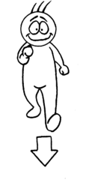
  - שם תואר: זקן______________________________
  - صفه ونعت : عجوز
  - לעבוד_______________________________
  - للعمل
  - פה____________________________
  - هنا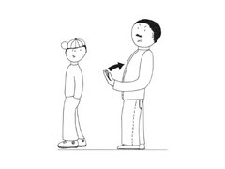
- to work
  - גבר___________________________
  - رَجُل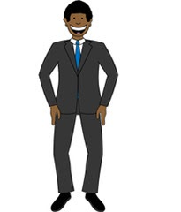
  - פועל: בא__________________________
  - فعل: يأتي
  - למה?____________________________
  - لماذا?
  - לעבוד_______________________________
  - للعمل
- here
  - פועל: בא___________________________
  - فعل: يأتي
  - למה?________________________________
  - لماذا?
  - גבר_____________________________
  - رَجُل
  - פה________________________________
  - هنا

3 True/False questions
- old → שם תואר: זקן
صفه ونعت : عجوز
True/ False
- man → למה?
لماذا?
True / False
- Why → לעבוד
للعمل
True / False
Google Forms:
https://docs.google.com/forms/d/e/1FAIpQLSeQZffBS0OIJ7AknxFzo8utiWNlbIVhYzc9s5E5LwjcGbduCg/viewform

What is the meaning (המשמעות/تعني) of the word?
1. again = (12 points)
never
one more time
always
now
The pronoun (מלת גוף/ضمير) "they" can relate to (מתיחס ל/يُنسَب الى)
2. they = (12 points)
a man
two or three people or things
you
Fill in the missing words. (השלם את החסר/أكمل الناقص)
3. Mom: "Where are you Sam?" "Sam: _____________, in my room"(14 points)
at school
teachers are
swimming
I am here
Other:_____________________________
4. "The ____________ is playing the guitar."(12 points)
woman
girl
baby
man
5. Old What's the opposite? (ההפך/مضاد)
now
tall
young
fat (14 points)

6. What is the meaning (המשמעות/تعني) of the sentence?
“What's the problem?”
מה הבעייה? / ما المشكله؟
מה לכתוב? / ماذا أكتب؟
מה החלטת? / ماذا قررت؟
איך לצייר? /كيف أرسم؟ 12 points

7. to come
לרוץ /يركض
ללכת/يمشي
לבוא/ يأتي
לכתוב/يكتب 12 points

8. What is the English word for:
למה /لماذا
what
why
who 12 points

Listening:
Lesson #1

A friend in need
Video and questions: https://learnenglishteens.britishcouncil.org/skills/speaking/intermediate-b1-speaking/friend-need

Text
Makayla: “Hi Gemma, you look terrible”
Gemma: “Hi Makayla, I haven’t slept
Makayla: “Are you OK? What’s the matter?”
Gemma: “Well, you know that photo I sent to Clare on Friday night?”
Makayla: “Yeah?”
Gemma: “Well, she sent it to Justin.”
Makayla: “Oh no! How could she do that. It obviously was only for her.”
Gemma: “I know, I thought she’d find it funny.”
Makayla: “well, it was quite funny. But, you didn’t expect her to send it to anyone.”
Gemma: “No, of course not! Especially not Justin! It’s so embarrassing!”
Makayla: “Ah well, don’t worry. I know how you feel, though.
Gemma: “And what if he puts it on Facebook or something? What if my mom sees it?”
Makayla: “No, no.. Don’t worry- he won’t. It’s not that interesting for him or anyone else, to be honest.”
Gemma: “But what if he does?”
Makayla: “He won’t. But, maybe ask Clare to speak with Justin. Get him to delete the photo.”
Gemma: “Yes, maybe. But that might just make him even more interested.”
Makayla: “Yeah, true.
Gemma: “What do you think I should do?”
Makayla: “I’d just try to forget about it if I were you.”
Gemma: “But I’m so annoyed with Clare”
Makayla: Maybe speak with Clare. Tell her how you feel. She shouldn’t share people’s private photos.
Gemma: “OK, Yes. Thanks for the advice Makayla. I’ll talk to her.”
Makayla: Good idea. And don’t worry, just be careful and don’t send any nore embarrassing photos!”
Gemma: “Yeah, I know. I won’t.

Test

Are the sentences true or false?
1. Gemma is stressed and upset.
True/False
2. Gemma sent a photo to Justin.
True/False
3. Gemma is worried about who else might see the photo.
True/False
4. Makayla thinks everyone will be interested in the photo.
True/False
5. Gemma thinks it's a good idea to ask Justin to delete the photo.
True/False
6. Gemma is angry with Justin.
True/False
7. Gemma likes Makayla's suggestion of speaking to Clare.
True/False
8. Makayla reminds Gemma not to send any more embarrassing photos.
True/False
More tests you can find here:
https://learnenglishteens.britishcouncil.org/skills/speaking/intermediate-b1-speaking/friend-need
Lesson #2
Future homes.
(Listening and Vocabulary) https://app.wizer.me/preview/WXD30O

Good morning, today I’ll give you a taste of the future.
From the latest in home design (החידושים האחרונים בתכנון הבית) to incredible gadgets, I look at how we could be living in the future.
A hot shower is a great start to the day, but this is not a simple shower. It uses rainwater collected from the roof and heated by solar energy. That’s heat from the sun.
Let’s look at some of the most modern houses in the world. Each one (כל אחד), was built as an experiment (ניסוי). They have the latest technology and ideas for living. Some of these houses can evolve (לגדול.להתפתח) as people’s lives change. Thinking of having more housemates (דיירים בבית)? Add on another layer (שכבה) like children’s building blocks (אבני משחק).
Peter White is the marketing manager of the Innovation Park (אזור מגורים חדשני) where the houses are built.
Interviewer: “Peter, are these houses really a glimpse (מבט חטוף) of the future?”
Peter: “They are. In the next few years, we will live in houses that look like this.”
Interviewer: “Just how much do they vary from ordinary houses?”
Peter: “In some ways, they’re very similar- the kitchen, the bathroom, the television are just like now. But the technology in the houses makes them much more energy efficient (יעילים מבחינת אנרגיה).
You may have seen the next invention (המצאה) in the movies, and it could mean no more lost keys in the future. It’s called fingerprint recognition technology (טכנולוגיה לזיהוי טביעות אצבעות), and it lets you back in.
Now, this control panel is the brain of the house. You can set the temperature and the shutters (תריסים) close automatically when it’s hot outside. And this is one of my favorites: It lets you control the music in every part of the house. So how about this?
Now, can you guess what this is? It redefines the simple chair. This rocks, and it’s a library as well. So, I can grab my favorite book and just sit back and relax.. I think I can spend some time here. So, do you mind coming back a little later?
I asked some people who were interested in house design what they would like to see in the house of the future.
“I would love a self-cleaning house”
I would like an eco house that uses renewable energy and doesn’t impact the environment”.
“I’d like a device that could carry me up to bed when I feel tired.”
I’d like a house where I could watch football in every room.”
“In my house of the future, I’d like a robot man that I can turn off

Test
Fill in the gaps with the appropriate words.
Difference, change, lost, control panel, every, kitchen, floor, entrance doors, rainwater, temperature, solar energy, energy.
The shower will collect______________ from the roof and the water will be heated by______________________ .
Some of the houses will evolve as people's lives _____________________ . You will be able to easily build an additional __________________________ onto the house.
The houses of the future will be very similar to our houses now they will have ____________________________ , bathrooms, living rooms. The__________________________ will be that they will be much more energy efficient, that means they will need less_____________________________ .
We will open the______________________________ to our houses through fingerprint recognition, so this means no more_______________________ keys.
The brain of the house will be a ____________________________ , with it you will be able to close the shutters, to regulate the_______________________ , and to control the music in________________________________ part of the house.
What would the two women and the two men like to have in their future homes? Use the following statements to complete the table below.
where it is possible to watch football in every room
a self-cleaning house
a device that carries you up to bed
a house using renewable energy
a robot man that can be turned off
WOMEN: | MEN:
Writing: (2 lessons) 5 points First letter: Read and answer questions
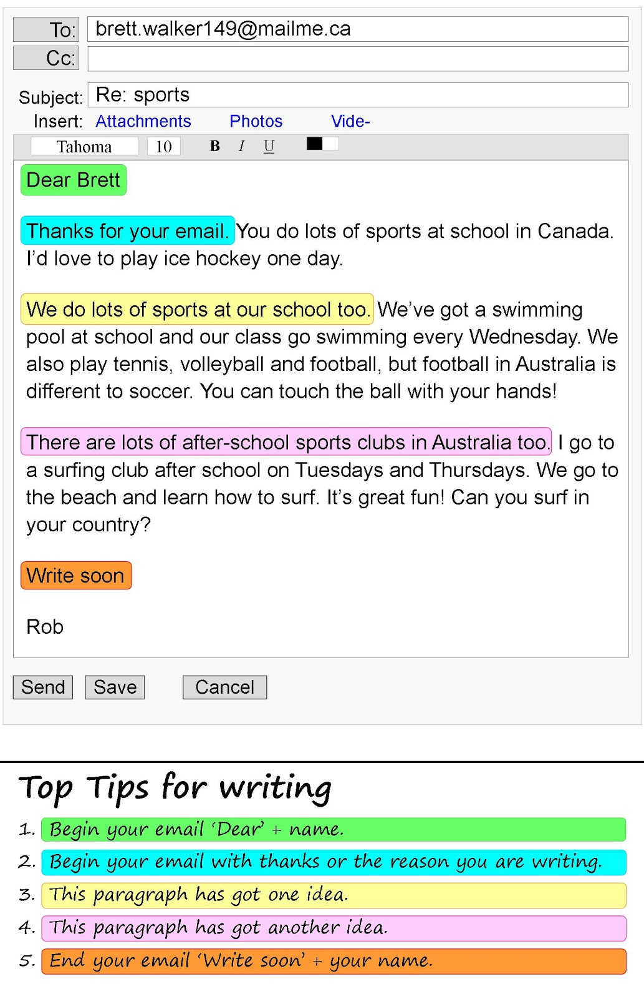

An email about sports
Are the sentences true or false?
1. Rob is from Canada.
True/ False
2. Rob wants to try ice hockey.
True/ False
3. There is a swimming pool at Rob's school.
True/ False
4. Rob goes swimming on Tuesday and Thursday afternoons.
True /False
5. Rob thinks football in Australia and soccer are the same.
True/ False
6. Rob often goes to the beach.
True/ False

Second letter: Read and answer questions
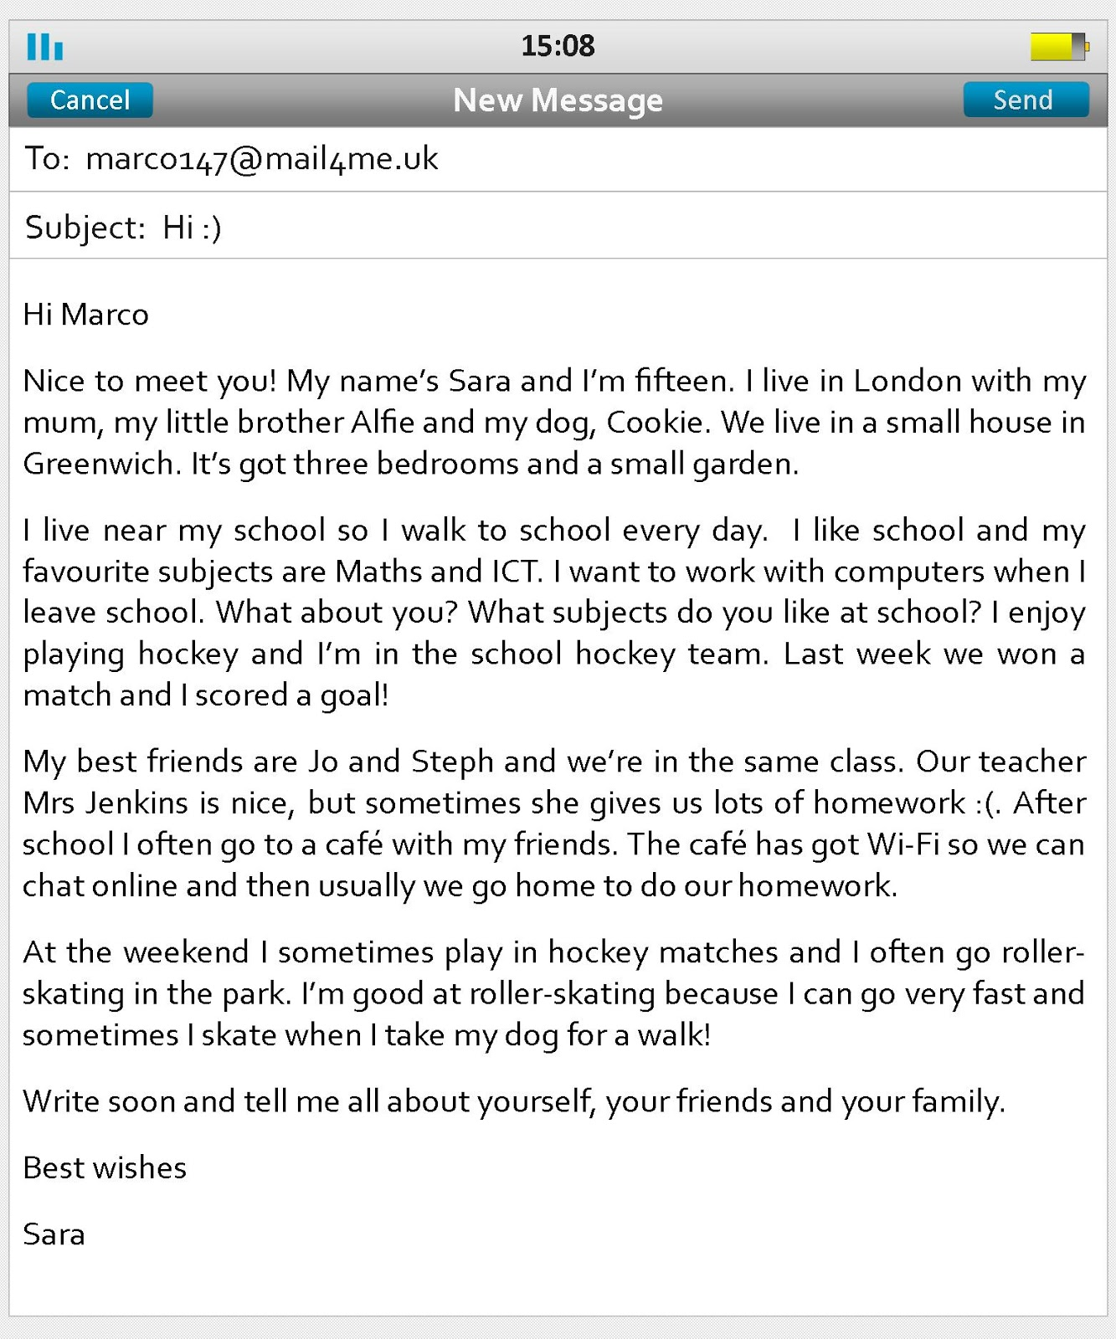

An email to a friend
Match the two parts of the sentences.
Sara sent an email___________________________________________
After school Sara and her friends go___________________________
Sara lives in London with her family___________________________
Sara likes studying maths____________________________________
Sara is close friends________________________________________
Sara likes to play hokey and__________________________________
- to the café and use the Wi-Fi.
- to Marco.
- go roller-skating.
- and dog, Cookie.
- with Jo and Steph.
- And computers.
Study the following letters. (optional)
Hello Alex
Thanks for your letter about you and your family.
It will be great to tell you about me and my family.
I am fifteen years old. I have got brown hair and gray eyes. I am tall and fat. :)
I live with my father, mother and my younger sister in a big house.
The house has a garden, pool and small car park.
My school is near my house. It is a little far from less than 1 kim. So I walk to school.
Maths and Chemistry are my favorite subjects. One thing I like about them is that I love numbers.
After school I often play hockey with my friends.
My closest friends are James and Mihai. They are very funny and kind.
Looking forward to your response.
Best regards
Lancer

Hi Jimmy,
My name is Nathan and I am 13. I live in a big house in Brussels with my parents and younger sister. There are 2 bedrooms and 2 study rooms and 1 big living room with a piano.
I live far from school so I go to the school by school bus. My favorite subjects are P.E. and ILT. My teacher is kind and handsome. But he sometimes gives us too much homework. I like baseball, swimming, tennis, football and hockey as sports. I like tennis for the best. So I really want to be a professional tennis player when I leave school. My favorite instruments are clarinet and piano.
My best friends are Sami and Daniel who’s from Turkey and S. Korea. We play football in school. On the weekend, we usually travel. I rarely go to the park by bike.
Write soon and tell me about yourself.
Best wishes
Nathan

Speaking ( Oral exam- 2 Parts) 15 points
Personal Interview for the Oral exam
(Your students can practice and write the answers as their preparation for the exam and not during the exam).

Teacher's questions | Student`s answers
1. What is your name/last name?
2. How old are you?

3. Where do you live?

4. Where do you study?

5. Do you have a favorite movie/band/book?

6. Do you have a pet?

7. What are your hobbies?

8. Do you have brothers and sisters?
9. What music makes you happy?

10.What are your goals for this year?

Questions about an informal letter/e-mail?

1. Did you write a letter/e-mail this semester?

2. Who did you write to?

3. What did you write about?

4. Did you get an answer?

GOOD LUCK!!!

A survey
Prepare 2 or 3 questions about travelling (or use the questions below) and ask your teacher, other students or your family. You can work in groups or in pairs.

Questions | Name: | Name: | Name:
- Did you plan traveling in August? If yes, where to?
- What is the most beautiful place in the world, in your opinion?
- Where would you like to travel next summer?

Grammar: (3 lessons) 5 points
Present Simple. Past Simple. Future Simple.

Present Simple.
1.1. Review
משפטים ב- present simple מתארים דברים שקורים באופן קבוע: יום יום, לעיתים קרובות או לעיתים רחוקות.
בדוגמאות הבאות, הפועל מסומן בירוק. במקרה של משפט שלילי ומשפט שאלה, לפועל מספר מילים: פועל עזר + פועל עיקרי.
Do I eat pizza every week?
I eat pizza every week
I don’t eat pizza every week

Do you eat pizza every week?
You eat pizza every week (הפועל זהה למשפט לעיל)
You don’t eat pizza every week

Do we eat pizza every week?
We eat pizza every week
We don’t eat pizza every week

Do they eat pizza every week?
They eat pizza every week
They don’t eat pizza every week

Does he eat pizza every week?
He eats pizza every week (נוספה האות S בסוף המשפט)
He doesn’t eat pizza every day (פועל העזר doesn’t)

Does she eat pizza every week?
She eats pizza every week
He doesn’t eat pizza every day

1.2. Test

- I_______ to work every day.
  - Go
  - Goes
  - Don’t read
- I _________________ you’re right
  - Likes
  - Finds
  - Think
- I _____________ the answer
  - Knows
  - Don’t know
  - Wear
- We ___________ enough time.
  - Has
  - See
  - Don’t have
- She ____________ cereal (דגני בוקר) in the morning.
  - Eats
  - Don’t eats
  - Doesn’t eats
- They _____________ emails every day
  - Like
  - Doesn’t write
  - Don’t write
- She __________ a lot of TV
  - Watch
  - Watches
  - Don’t watch
- He ____________ the newspaper
  - Read
  - Reads
  - Don’t read
- She __________ often
  - Dance
  - Dances
  - Doesn’t
- I ________ here on Mondays
  - Doesn’t come
  - Comes
  - come

Past Simple

2. Past simple verbs (regular and irregular)

https://www.gamestolearnenglish.com/past-tense-game/

2.1. Review & Practice

Present simple | Past tense
I stand at the bus station | I stood at the bus station yesterday
You write many letters. | You wrote her a letter last week.
They read a lot | They read a lot when they were kids.
I make cakes. | I made a cake yesterday.
You run quickly | You ran in a marathon last year.
We usually drive to the airport | We drove to the airport last night
They usually go to school on foot | They went to school by bus yesterday
I buy many pens | I bought a pen at the store three days ago.
I usually wear T-shirts | I wore a dress yesterday.
You put a lot of effort at school | You put a lot of effort before the exam.
I want a new bag | I wanted that bag but it was already sold.
I say yes a lot | I said yes when he asked for help.

2.2. Test

Verb | Past tense
stand | He _________ at the bus stop two hours ago.
write | When they were kids, they ____________ letters to each other
read | I __________ this book last year
make | Yesterday was my birthday. Mom _________ a cake for me.
run | I knew I was late, so I __________ as fast as I could
drive | My friends ____________ to Minnesota last year.
go | When I was a kid, I ________ to school by myself.
buy | I loved this chocolate so I __________ ten packs.
wear | Emma Watson ___________ a red dress in the Oscar award ceremony.
put | She didn’t remember where she ________ the car keys.
want | I know you _______ to go, but it was not possible.
say | She ___________ she would take him to the game, but she didn’t.

3. Future Tense

1) Your case is very heavy. I will carry it for you. (carry)
2) Sam will come to the party tonight. (come)
3) Ann won't drink coffee. She doesn't like it. (not drink)
4) Can you repair this clock? OK, I will do it tomorrow. (do)
5) It's very warm outside. I won't wear a sweatshirt today. (not wear)

3.1. Make the following sentences negative.
- It will be warm tomorrow→
- Dinner will be ready at six o'clock tonight. →

3.2. Rewrite the text in the Future Simple tense.
The long, hot days of summer end. There isn't much sunshine during the day and the nights are not warm. The days grow shorter and the air becomes cooler.
The flowers don't bloom and the leaves cannot make enough chlorophyll to keep them green. Then the other colors in the leaves begin to show. Leaves become yellow, orange, red and purple and later they drop from the trees.
The season of autumn comes. It lasts for three months.
But people don't stay at home. At weekends they often go for walks in the parks. Children like to stay outdoors and play football and other games. They know that winter is on its way, so they don't want to miss this wonderful time of the year – autumn.

