מדריך למורה 10 שנ"ל אנגלית 2021-2022

במדריך הזה תמצאו הרבה רעיונות לפרויקט ושיעורי דגם, טקסטים וקישורים לאתרים רלוונטיים. אתם יכולים לקחת מה שמתאים לשיעורים שלכם אבל לא חייבים.:)
בהצלחה
רכזת אנגלית
אלונה לרר
Table of Contents
Themes, areas of communication and learner activities 2
Links to Basic vocabulary, Texts, Speaking practice and Writing 3
Health (Food, Sport) 4
Travelling 6
Technology 15
Environment 17
Family and Friends (optional) 19
Personality:(optional) 21

Themes, areas of communication and learner activities

Unit | Themes/ Vocabulary areas | Areas of communication (suggestions) | Learner activities  (ideas)
1 | Health aspects: restaurants; food; food recipes; ingredients; sport; lifestyles; the quality of life | Discussing likes/dislikes; agreeing/disagreeing; persuading; planning future events. | Comparing reactions; role play; listening and discussion; presenting ideas to the class; comparing choices; completing a grid.
2 | Travelling: countries of the world and life in them; booking tickets; hotels; folk music; shopping online. | Discussing hypothetical situations; exploring preferences; justifying opinions. | Exchanging information; comparing choices; guessing game.
3 | Technology: inventions; new gadgets; computers; IT; virtual currency; developed countries (Japan, Germany…) | Talking about new  Gadgets and IT technology (past, present and future) | Discussion; Project: Visiting Trade Fair / Time travelling to 2050.
4 | Environment: litter and rubbish; weather, forecasting; public and private gardens; class/town environment. | Exchanging views; negotiating choices; expressing likes/dislikes | Completing a grid; listening and retelling; comparing choices; dialog; writing; discussion; group planning;
5 | Family and Friends: family tree; childhood memories; | Talking about the past; justifying opinions; agreeing/disagreeing; talking about behavior; discussing relationship | Discussion; exchanging anecdotes; group project; listening and predicting; family tree project; making word drawing
6 | Personality(Who am I?):  names, nicknames; appearance; feelings and reactions; good/bad luck; fears/phobias; ways of overcoming fears; personality traits; colors/shades; EQ. | Talking about yourself and other people; asking about other people; describing people/ personality; giving and receiving instructions; talking about likes/dislikes and intentions; making suggestions; persuading; narrating experiences; talking about customs; relating personal experiences; discussing emotions; giving advice; using metaphors | Recording information; guessing game; discussion; role play; group writing; using instructions; grid filling; vocabulary matching game Quizlet; guided fantasy; classifying vocabulary;

Links to Basic vocabulary, Texts, Speaking practice and Writing
Basic vocabulary for beginners:
https://learnenglish.britishcouncil.org/basic-vocabulary

Texts to practice for beginners:
https://learnenglish.britishcouncil.org/reading/beginner-a1-reading

Speaking practice for beginners:
https://learnenglish.britishcouncil.org/listening/beginner-a1-listening

Writing for beginners:
https://learnenglish.britishcouncil.org/writing/beginner-a1-writing

Health (Food, Sport)
Vocabulary health:
https://learnenglish.britishcouncil.org/intermediate-vocabulary/health
https://learnenglish.britishcouncil.org/basic-vocabulary/body-parts-1
https://learnenglish.britishcouncil.org/basic-vocabulary/drinks

Additional ideas for speaking activities and projects:
Sport
Reasons to do sport. Why do I need to do sports?
Water sport.
Ball games.
Winter sport (Mt. Hermon?) Popular destinations abroad.
Team sport (Rules)
Current sport news websites (reading headlines)
https://edition.cnn.com/sport
https://www.bbc.com/sport
Sport celebrities.
https://www.google.com/search?q=top+sport+celebrities&oq=top+sport+celebrities&aqs=chrome..69i57.6400j0j4&sourceid=chrome&ie=UTF-8
Food, eating out

Ordering pizza online. Popular pizza sites https://pizza.dominos.com/.
Samples of Menu (types of cuisine) (Vocabulary)
Role play in a restaurant
Cooking. Simple recipes with pictures or videos. Cooking in the classroom: salad, sushi (Wakame salad recipe below).
Project: Cooking show.
Fast food.
Junk food.
Kosher food.
Who is a Vegan?
Role play in a restaurant :Your friend is a vegetarian.
Specialties in different countries.
Food of your family(grandma`s specialties)
Family food/dining traditions.

Lesson 1.
Topic: Japanese food.
Project: Preparing Wakame salad.
Length: 15-20 min + time for eating

Trigger: put chopsticks on the table and ask what it is and who can eat with chopsticks. You can teach them how to use chopsticks or they can teach you.

Start with a discussion about Japanese food. What kind of food do Japanese people eat? How is it different from European and Israeli food. Ask for examples of Japanese food. Usually they name sushi and that's all:))
Here is a list of top 10 food to try in Japan: https://www.freelancer.com/contest/Great-Design-Japanese-Food-list-895240-byentry-11345893
Venn diagram: Food in Israel and Japan.
Venn diagram example:
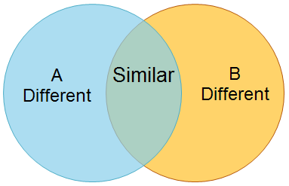

Video about Japanese traditional food: Typical lunch. How to cook with simple ingredients https://www.youtube.com/watch?v=h8hc2uSecvI

Wakame Salad Recipe:
1 glass of water
2 Tsp wakame salad
2 cucumbers
½ avocado
oil
soy sauce
sesame seeds
Put wakame seaweeds in 1 glass of water and let it “grow” there. You can see how its growing! Cut 2 cucumbers and ½ avocado.

Wakame seaweed What is it? Watch wakame grow in the ocean.: https://www.youtube.com/watch?v=OhOaH5LTfTs
Or ask your students to find out what it is in their phones.

Your students will never forget this lesson:)

Travelling
אוצר מילים- נושא חופשות, נסיעות ומלונות

Holiday vacation hotel travel room
Stay experience food entertainment party
Fly check-in check-out trip fun
Swimming pool beach together happy sunny

אוצר מילים ספציפי לטקסט

guest information enjoyable reception wrist band key-card

damage lose located exactly
charged pay attention

safety deposit box deposit valuables

Part I
Food and entertainment
breakfast – 08:00 – 11:00
dinner – 18:00 -22:00
swimming pool: open from 09:00 – 22:00 every day.
Shuttle to the beach: from 10 a.m. to 7 p.m. every round hour.
Gym – 10:00 – 19:00 Monday – Saturday
A special bus to the night parties in the city clubs: Sundays, Tuesdays, Fridays and Saturdays, at 23:30 and back from the city at 02:00, 03:00 and 05:00.

Part II
Hotel information for young guests
(based on a real document at the hotel "club B" in Majorca, Spain)
Dear guest! We hope you have a great holiday with us!
To ensure everyone has an enjoyable time, we would like you to pay attention to the following information:
Reception – the reception is open 24 hours a day. There is free coffee in the morning.
Experience team – located near the reception. Please see them in order to get information and ideas for a great time – days and nights.
Wrist bands – you should wear the wristband all the time. If you lose it please go to reception and replace it. You will have to pay for a lost wristband.
Key cards – please keep the key card with you at all times.
Room damage – when you enter the room please check that everything is o.k. You should return the room at check-out exactly as you found it, or you will be charged for the damage.
A safety deposit box – please rent one in the reception to put all your valuables there.
A deposit – you have to leave a deposit at check-in. You will get it back when you leave, and the room is not damaged.

למורה:

לאחר למידה ראשונית של אוצר מילים, קיראו יחד את הטקסט. סמנו את המילים שלמדתם וחיזרו עליהן.
דיון בטקסט – במידת האפשר באנגלית, אך אפשר כמובן בשפת האם.
עבור מי נכתב הטקסט שקראנו? האם הוא שכיח בבתי מלון בדרך כלל? אילו סעיפים הם סעיפים שפונים בפרט לקהל הצעיר? מדוע לדעתכם? חפשו דוגמאות מן הטקסט.
בהמשך מופיעים משפטי תירגול – השלמת משפטים עם אוצר המילים מתוך הקטע. כדאי לבצע התרגילים כדי להטמיע את אוצר המילים.

חלק שני של הטקסט הוא מתוך דף מידע לאורח אשר מופיע באופן סטנדרטי במלונות:

Examples of questions: (from both parts of the text)
1. Complete the sentence with TWO words: (lines 16-17)
The guest has to give a deposit at ____________________ and he/she will get it
back at _______________________ if the room is ok.
2. Circle the correct answer YES or NO (lines 26-27)
There is a bus to the city every day. Y/N

3. Answer the question:
Can you get breakfast at 12:00? (line 21)
_____________________________________________________________
4. Complete the sentence: (lines 10-11)
If you lose your wrist band you will have to ____________ for a new one.
5. ** (a more challenging question) Complete the sentence: (lines 5-6)

If you follow the instructions, you will have a ____________________ time (more than one answer is accepted)

Grammar:
1. Imperative: a sentence form that is used for stating requests, instructions and orders. See lines 7, 11, 12, 14.
2. Modals – optional. See lines 9 (should), 15 (have to).

Trips and travels around the world
סוג הטקסט: travel / holiday ads

למורה: פעילות אפשרית סביב הטקסטים:
1. אוצר מילים - למידה ותרגול על פי הטבלה המצ"ב
2. הכרת סוג הטקסט: מודעה.
דיון: מה מאפיין מודעה? (כותרות גדולות, טקסט אינפורמטיבי/משכנע, שימוש גרפיקה, פונטים, צבעים, תמונות)
נשים לב למבנה החוזר במודעות – שימוש בציווי imperative
3. הוצאת מידע מהטקסט
המאפיין את המודעות המצ"ב: כולן אמתיות ונלקחו מאתרי אינטרנט קיימים.
אין צורך לעבור מילה אלא להתרשם מן המודעות להתייחס לנקודות המתאימות לכל מודעה, על פי הדגשים הבאים:

מודעה מס' 1 – זיהוי שמות הערים/המדינות, כבסיס לתרגול מדינות וערי בירה.
דקדוק – present progressive
מודעה מס' 2 - זיהוי המבנה we have ואוצר מילים מתוך הרשימה
בניית משפטים לדוגמה כגון We have indoor swimming pool rooms ותרגום המשפטים
מודעה מס' 3 - מבנה הציווי, דיון במשמעויות של המילה book.
איזו משמעות אתם מכירים? האם היא מתאימה כאן? אז מה יכול להיות פירוש המילה בהקשר הזה?
האם מכירים את האתר booking.com? כיצד הוא מתקשר לפירוש המילה book כפי שהוא במודעה?
מודעה מס' 4 – במה מדובר? לכוון את התלמידים לכותרות המודגשות – לתרגם יחד את המילים single / double - לדון בפירוש בהקשר של חופשה ושל המילה room.
מה משמעות המספרים המופיעים? היכן נמצא המלון המדובר? מהי ההצעה הזולה ביותר? מהי היקרה? מדוע?
דליית מידע scanning – תחת כל הצעה ישנה רשימה. אפשר לדלות פרטי מידע שמוכרים לתלמידים מאוצר המילים שלמדו

בטבלה הבאה מרוכזות המיומנויות ואוצר המילים העולים מכל מודעה
מודעה מס' | אוצר מילים | דקדוק | דגשים מיוחדים- מאפיינים של מודעות לעומת טקסט מדעי רגיל | הערות
1 | Destination  Magical  Holiday | שימוש בציווי  Present progressive | כותרות בגדלים וצבעים שונים  פרטי יצירת קשר  שימוש בגרפיקה
2 | Perfect  Package  Resort  Indoor  Adventure  Campfire | שימוש בציווי  have | רשימה – נקודות עיקריות
3 | Offer  Holiday  Deposit  Price/ half price  payment | מילה שהיא גם שם וגם פועל במשמעויות שונות (book) | שימוש בפונטים שונים במקומות שונים בדף כדי להציג מידע | מיומנויות מיוחדות: חיפוש במילון/מילונית אחר מילים שיש להן כמה פירושים
4 | Season  special | אין | כמה שיותר מידע בכמה שפחות מקום  Scanning – מיומנות איתור פריטי מידע בתוך הטקסט | מיומנויות מיוחדות: דליית מידע מרשימה,  השוואה בין מודעות

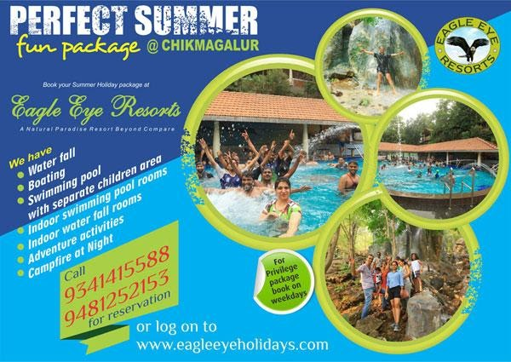
1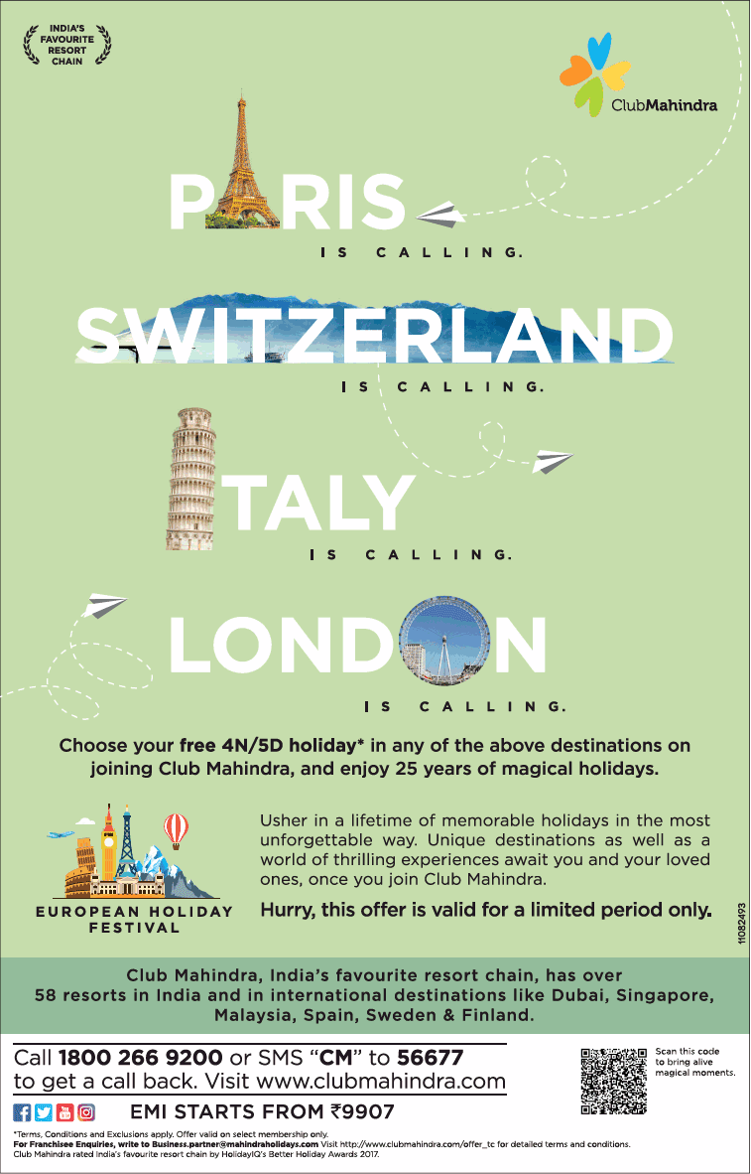
2
3
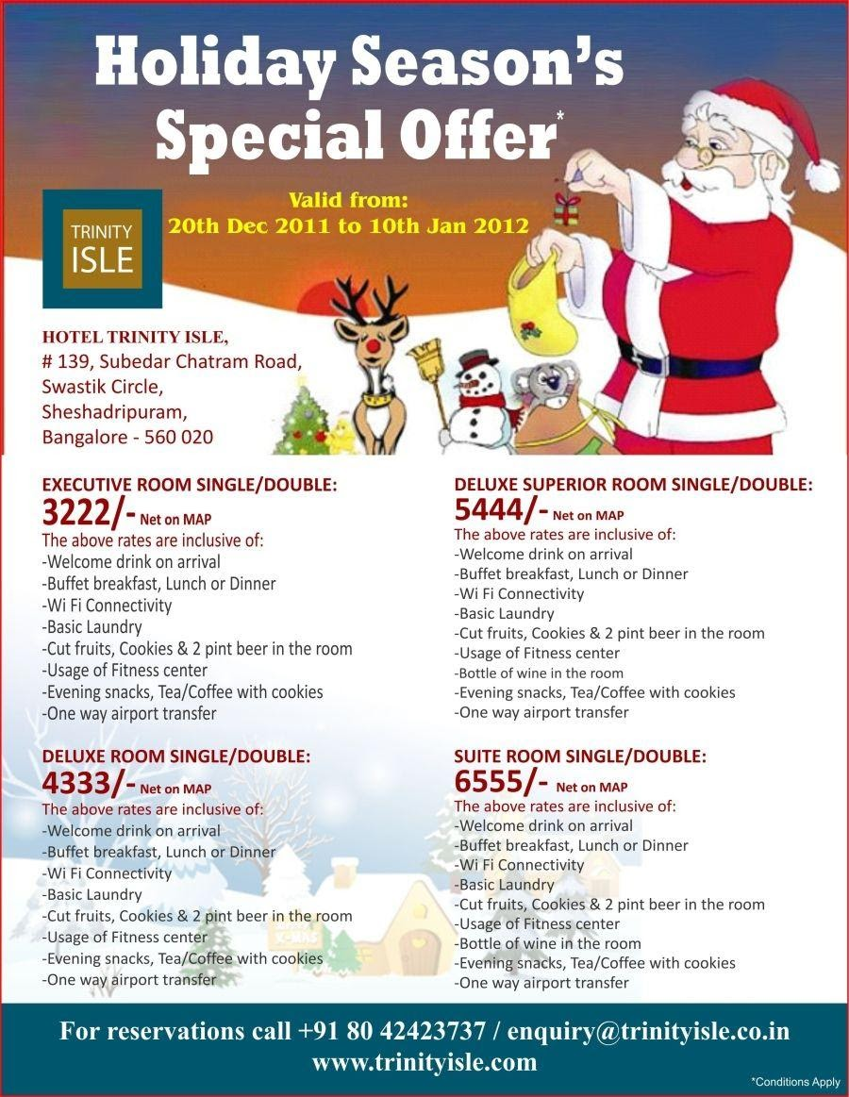

Additional ideas for speaking activity and projects:
1 My trip with family/friends in the summer (Project: Experience of a lifetime)
2 Visiting family/friends abroad (Photo Presentation: Visiting family/friends)

Talking about the most popular destinations:
South America, The US, New Zealand, Australia, Thailand, Europe ...a student decides on a destination.
We learn about these countries or a chosen country, vocabulary, videos, google maps, instant street view. Videos of people from these countries, learning about cultural differences.
How and where to buy tickets, deals. TripAdvisor. Planning your trip.
What do you need to take with you? (Vocabulary) Quizlet.
Risks. To do list and must haves. Practical tips for those who travel. Dangerous spots in the world. How to avoid problems while travelling.
Ordering a Hotel/Hostel/backpackers/hosting organizations.

Talking to a tourist in Israel and as an Israeli tourist abroad
Role play: helping a tourist to find the way. Talking about Israel and city they are from. What can you tell about your country? What are you proud of in your country?

Shopping

Online and Offline shopping.
Popular sites for online shopping:

AliExpress https://best.aliexpress.com/?lan=en,

Ebayhttps://www.ebay.com/?ef_id=CjwKCAjwkenqBRBgEiwA-bZVtlvcdlUyaAwcxAZVBtjx84rgisV0qOHTtIBf4cWsdwzWOgEKhWsH7xoCziEQAvD_BwE:G:s,

Amazon https://www.amazon.co.uk/.

Vocabulary: Quizlet https://quizlet.com/
Categories of products. Placing orders and shipping.

Ways of payment online. PayPal, Bit, Credit Card, virtual currency.
Project: My first real purchase online.

Technology

Read this online safety poster with your students and discuss this topic:
https://learnenglishteens.britishcouncil.org/skills/reading/elementary-a2-reading/online-safety-poster

Vocabulary:
https://learnenglishteens.britishcouncil.org/vocabulary/beginner-vocabulary/technology

School poster project:
https://learnenglishteens.britishcouncil.org/skills/writing/beginner-a1-writing/school-poster-project

Online safety conversation:
https://learnenglishteens.britishcouncil.org/skills/listening/beginner-a1-listening/online-safety-conversation

Reading: Why Charlie is so cool?:
https://learnenglishteens.britishcouncil.org/study-break/graded-reading/why-charlie-so-cool-level-1

13 Information Technology Vocabulary Words Every English Student Should Know

1. Monitor
The noun monitor refers to the video screen used to display information on your computer.
2. Connect
The verb to connect is used to describe the action of establishing (making) communication with the Internet or with another device (computer equipment) such as a monitor, modem, etc.
3. Install
The verb to install means to set up or make a computer or application (software program) ready for use.
4. Network
The noun network refers to a system of connected computers and other devices such as printers that exchange data with each other. A private office network is known as intranet.
5. Access
The verb to access, when used in IT, means entering and using a computer, website or application.
6. Log in
Some websites and applications need you to log in before you can enter and use them. To log in refers to the process where you enter certain information before you’re allowed to access a website or application.
Sometimes the terms sign in and sign out are also used.
7. Download
To download is a verb you’ll often hear in IT to talk about transferring data or information from a main computer source to another device.
8. Upgrade
It’s not unusual to hear this word in a fast-changing field like IT. The verb to upgrade means to bring your computer (or other device) up to date with the latest hardware or software.
9. Analyze
The verb to analyze is used quite often in IT when there’s a need to study data, information or even a technical problem closely. For instance, you might analyze product trends or a problem with your communications network.
10. Browse
The noun browser, as you may already know, refers to the program on your computer that allows you to open and use websites on the Internet.
11. File
The noun file in IT refers to a collection of data or information organized under a specific name and stored in a computer’s folder.
12. Blog
Do you have a blog? The noun blog refers to a website where you write about your personal experiences, opinions and interests.
13. Back up
The phrasal verb back up is often used in IT to mean making a copy of data and files to protect them against accidental loss.
So there you have it. With this information technology vocabulary in hand, your students are ready to speak confidently and keep up with the latest developments in IT.
Remind them, practice makes perfect.
Log into your school computer and start teaching!

Environment

נושא על: איכות הסביבה
תת-נושא: מיחזור ותרומה להפחתת גזי חממה
סוג הטקסט: טקסט מדעי.
- מצגת מקסימה באינטרנט שמתאימה לתלמידי אנגלית
http://www.eslileaders.org/uploads/1/4/3/5/14352270/refuse_reduce_reuse_recycle_ppt.pdf
- טקסט מדעי עם פניה ישירה לקורא, המבוסס על אינפורמציה מכמה אתרי אינטרנט:

The four R's
Do you care about the planet we live in? Do you want to help save the earth from global warming?
Here are some things you can do with 4 simple actions. They are called "The Four R's".
Refuse- (לסרב)
Say "no" – to plastic bags, to things that you don't need, to disposable dishes and to packages. Try to use less and not more. You will also save money!
Reduce – (לצמצם
Think about what you use and buy. Could you use less? Use less things – less water, less garbage, and less energy. Take the bus, not the car.
Reuse – (שימוש מחדש)
Use things more than once. For example: little brothers can take clothes from older brothers. Soda bottles can be filled with water. Think about other ways to reuse!
Recycle – מיחזור
Everybody has heard of recycling by now. We have special containers for that, and we can recycle plastic, paper, metal and even electronic devices!

אוצר מילים:
Earth – כדור הארץ  Planet – כוכב | Less  פחות
Global warming התחממות גלובלית | Water  מים
Plastic bags  שקיות פלסטיק | Garbage זבל
Disposable  חד פעמי | Save לחסוך
Packages  אריזות | Device – מכשיר
Containers מיכלים

Family and Friends (optional)
Idea 1

Topic: Names and what they mean to us.
A short text or 2 with English names like John, Anna, David…

Ask your students to find Names and highlight them (you can also talk about capital letters here)
Let them write the names.
Boys` names:
Girls` names:
Names for boys and girls:

Idea 2
Topic: Is Rosita your dog?

Write down 3 first names that are important to you. They can be names of friends, family, people you don't like, animals(pets), film stars, people in books, people in politics, teachers.

One student reads out the first name on his or her list. The others ask one question each. When the answer is “Yes”, you get one point. If your first question gets “Yes”, you get 2 points.

Idea 3

Topic: The big apple…
Prepare Pictures of The Big Apple (NY)

Cities can have other names. The big Apple (New York), The Mini Apple (Minneapolis). Let your students give your town a new name. Discuss it with a class. Can you all agree on a new name?

Idea 4

Topic: Once a child, always a child?

Ask your students:
When you were a child, what were your favorite games, toys?
Where did you play the game?
How often?
Did you play with other people?
Who?
How old were you?

Idea 5

Topic: When does someone stop being a child?

Choose one answer from this list or write your own.

Someone stops being a child when he or she:

- smokes their first cigarette
- First has a boyfriend or a girlfriend
- Starts buying their own clothes
- Drinks a glass of beer or wine
- Drives a car
- Leaves school
- Gets married
- …………….

Personality:(optional)
Idea 1
Topic: Fears and Phobias
Find pictures of a bat, rat, crab, mosquito, snake, frog, spider.

Let your students match pictures and words.
Which creatures have:
- Sharp teeth:
- Tails:
- poison:

Here is an interesting list of phobias: http://phobialist.com/

Idea 2
Topic: EQ. Emojis.

What are emojis? https://emojipedia.org/people/
What is your favorite emoji? What is the most annoying emoji?
Using emojis answer the questions:
- How do you feel now?
- How do you feel when you are hungry?
- How do you…
Tell us about yourself using emoji (Family, hobbies, friends, likes/dislikes)
Tell us about your trip…. weekend...last birthday party…
Create a WhatsApp dialogue using only emojis.

אלונה לרר
רכזת אנגלית

