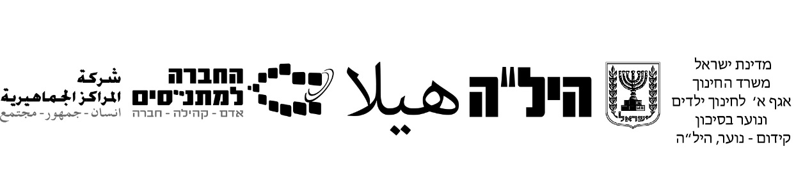

English – For 12 Year Diploma

Updated Curriculum -

The Structure and Content of the Exam –2022/23

In accordance with Module B Bagrut Exam -

School Assessment Evaluation –Adapted to Module B

Starting as from Summer 2018

- 12 year Diploma Exam- the Final Scoring Structure:
- A magen grade ציון מגן - -40 %
- A computerized Test – 40 %
- An oral exam (10 personal questions to the student about him/herself)– 20%
______________
100 % – total
- A magen grade ציון מגן:
The magen grade ציון מגן comprises two parts:
- 2 projects with grades (ex. Unseens, grammar tests, presentations, vocabulary quizzes)
- 1 מתכונת, which is a sample test הדמיה.

Please note
- The teacher will examine the student and the students’ grades ציוני מגן need to be reported to the MENAHEL HASKALA (The manager in charge of the pedagogical aspects) –up to one day before the date of the exam, at latest.
- We are instructed by the HILA headquarters, from the Ministry of Education, that if a magen grade isn’t reported and doesn’t appear in the system - up to a day prior the exam,
the student won’t be able to get a grade, because the evaluator will not be able to insert a grade into the system. That is: The exam will not be taken into account and the final grade will be a failed grade.
- Please be sure to give a magen grade and make sure that this grade is typed into the system.
- The winter exam will include ONE part:
Reading Comprehension: (100 points)
An article

Duration of the exam- Two hours.

3. The Details of the content of the computerized exam - for the 12 year diploma exam are as follows:
a. The structure of the 12-year diploma exam is adapted to the content and structure as in the external Module B exam - or as a School Assessment Evaluation, as done in the schools. The grade of the 12-year diploma exam is recognized as a module B grade and will be recognized as Bagrut only when 3 points have been accomplished.
b. The exam- reading comprehension-
Includes ONE text of approx. 300 words.
This part has 10 questions (Each question is worth 10 points).
- Bank of words- There are approx. 10 words in the bottom of the text to assist students’ comprehension. The words are translated to their mother tongue: Hebrew/Arabic/Russian.
- There are various types of texts, which may appear in the exam: a descriptive or informative text, an interview, an e-mail or informal letter, a book or film review. All the above will contain content which is familiar and close to the students’ world. Such as: animals, computers, gadgets, applications, music, fashion, trips, looking for work, jobs, relationships, sports, films, vehicles.
This coming semester – winter 2022, the type of text which will appear in the exam will be a descriptive text (an article).

4. Types of questions in the exam:
Reading comprehension text
10 Closed Questions: Choose ONE/TWO correct answers (multiple choice/American questions).
A total of 10 questions.

The teacher is required to give a magen grade ציון מגן, which relates to the achievements of the student in the computerized exam.

5. Working recommendations for the teachers in order to prepare the students for the exam:
a. Preparation of working online with a text - creating "anchor" tasks prior the actual reading and answering questions about the text (marking words, translations etc.)
b. Teach students how to work with an electronic dictionary.
The text in the exam will be in friendly large font and big spaces between lines.
- Each question will be accompanied by a referral to the paragraph in the text. For example: (paragraph IV) This exam there will be VI paragraphs.
- It is advisable to work with the students on vocabulary (you may find the list on the site) and repeat the vocabulary in a variety of ways. Each lesson can start with newly acquired words.
- It is advisable to work with your students on vocabulary and texts related to mistakes, failure and different kinds of difficulties we face in our lives. We don`t give up, we learn from our mistakes, we work hard. In the end, we`ll see our dreams come true.
- See the sample test and plan your lessons.
- Grammar teaching:
Pronouns
BE- present+ past+ future
Present simple
Present progressive
Past simple
Past progressive
Future simple
WH questions
Adjectives /comparative adjectives
Adverbs
Nouns
Prepositions
Have/ Has
Modals

